|  |  |  |  |
| --- | --- | --- | --- |
| C:\Users\David\Dropbox\rossmoyne.png  **Reading Time**: An initial **2 minutes** | **MATHEMATICS METHODS : UNITS 1 & 2, 2020**  **Test 1 – (10%)** 1.2.1 – 1.2.8 | | |
| **Time Allowed**  45 minutes | | **First Name Surname** | **Marks**  43 marks |

**Circle your Teacher’s Name:** Benko Bestall Fraser-Jones Goh Koulianos Luzuk Rudland Tanday

|  |  |
| --- | --- |
| **Assessment Conditions: *(N.B. Sufficient working out including diagrams must be shown to gain full marks)***   |  | | --- | | * Calculators: Allowed * Formula Sheet: Provided * Notes: Not Allowed | |

**Question 1**

( 1, 1, 1 & 1 = 4 marks)

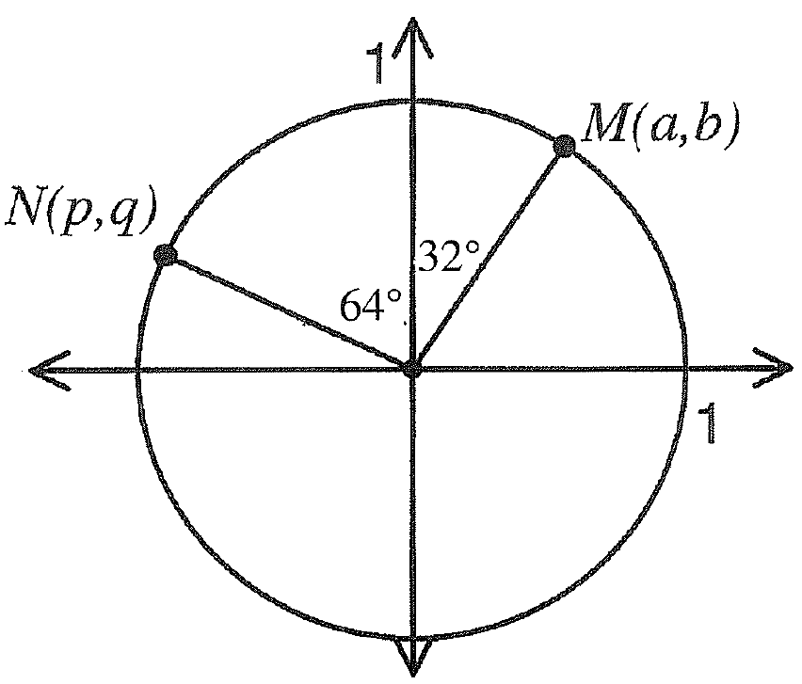

Two points *N(p,q)* and *M(a,b)* are plotted on the unit circle above.

In terms of *a*, *b, p and/or q,* determine the following.

1. sin 26˚

1. cos 154˚
2. cos 26˚
3. tan 122˚

**Question 2**

(2, 2 = 4 marks)

1. Express the following angles in radians. Answers should be simplified, in exact values and in terms of .

(i) 45**˚** (ii) 160 **̊**

(b) Express the following angles in degrees.

(i) $\frac{3π}{5}$ radians (ii) 2.2 radians (round to nearest degree)

**Question 3**

(5 marks)

A parallelogram has side lengths of 25 and 30 cm and an area of 700cm². Find the length of the longest diagonal.

**Question 4**

(4 marks)

Triangle *ACO* is a right angled triangle with *OA* = 10cm, *AC* = 20cm and the size of angle *OAC* = 90**˚**. A circle of radius 10cm is drawn, centre *O*. Find the area of that part of the triangle *OAC* not lying in the circle.

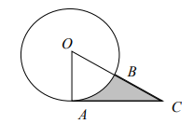

**Question 5**

(4 marks)

Points *A* and *B* lie on the circumference of a circle with centre *O* and radius 12cm. If the major arc *AB* has a length of 60cm, find the area of the minor sector *AOB*.

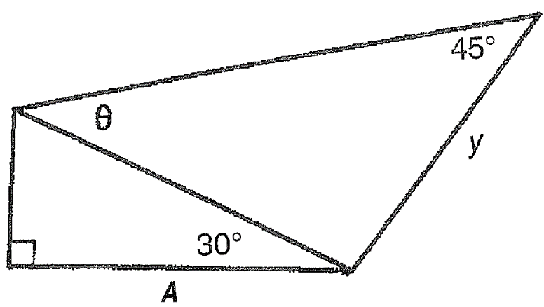**Question 6**

(4 marks)

For the diagram on the right show that

*y =* **2 $\sqrt{2}$***A* **sin*θ*** *A*

**Question 7**

(6 marks)

The diagram below shows two overlapping circles of radii 4 cm and 5 cm, where the size of angle *MAN is* 80°. Determine the area of the region common to both circles.

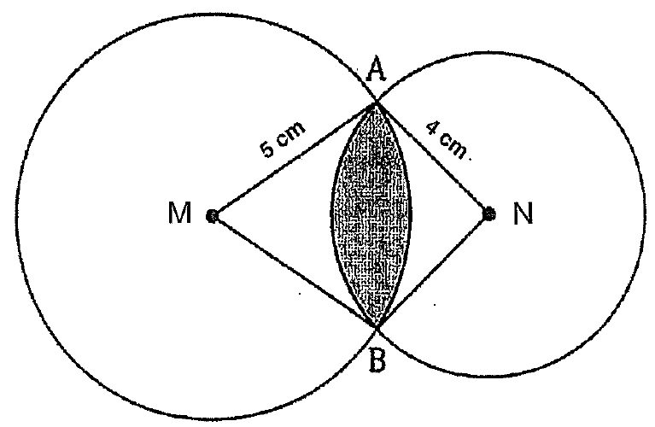

**Question 8**

(6 marks)

Ken and Sofia set out in different directions from their campsite. Ken walks 2150m

on a bearing of 316°, whilst Sofia walks for 2000m on an unknown bearing. When they finish walking the distance between them is 2696m. What are the possible bearings that Sofia could have used?

**Question 9**

(6 marks)

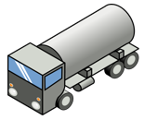A tanker, truck A, is loaded with petrol however receives a tyre puncture. Another tanker that is empty, truck B, is sent to be loaded with all the petrol from the tank of truck A. Both trucks have cylindrical tanks.

Truck A has a tank of radius 1.7 m and a length of

6 m. The tank is filled with petrol to a height of 1.58 m.

Truck B has the same length but a radius of 1.5m.

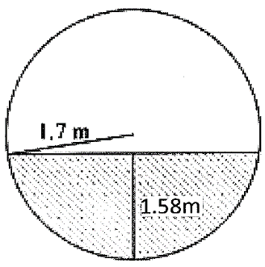

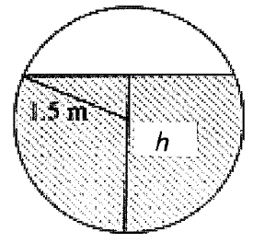

Circular ends of the petrol tanks.

The drivers are concerned as Truck B has a smaller tank. How high  will the petrol reach in the tank of Truck B?

**End of Paper**